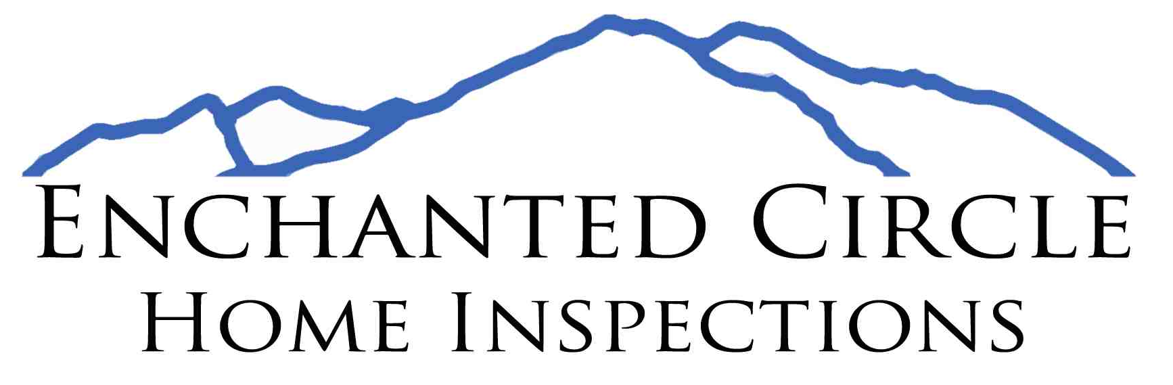

{inspection image}

111 Amber Lane

Ranchos de Taos, NM 87557

(575) 779-1983

enchantedinspections@gmail.com

**Inspection Report Prepared For:**

{Name}

{ClientAddressLine1}

{ClientAddressLine2}

{Client City State ZIP}

{Client Phone}

{Client Email}

**Inspection Address:**

{InspectionAddressLine1}

{InspectionAddressLine2}

{Inspection City State ZIP}

**Inspection Date:**

{Today’s Date}

**Selling Agent: {Selling Agent}**

**This report is the exclusive property of the Enchanted Circle Home Inspections LLC and the client whose name appears herewith, and its use by any unauthorized persons is prohibited. This inspection is conducted under** [**ASHI standards of practice**](http://www.homeinspector.org/files/docs/standards_updated3-4-2015.pdf)**. It is a visual, non-invasive, non-destructive inspection of readily accessible areas and conditions at the time of the inspection. This report identifies Material Defects discovered. This inspection excludes the presence or absence of rodents, termites, or other insects or damage caused by them, mold, or mildew, indoor or outdoor air quality, radon gas, lead paint, asbestos, formaldehyde or other pollutants and Toxic chemical, water quality, underground tanks or wells, septic, and other sewage disposal systems. This inspection is not a warranty. Enchanted Circle Home Inspections LLC is limited to the amount of the inspection fee. The customer must initiate any suit against Enchanted Circle Inspections within one year after the date of the inspection report being delivered or emailed to the customer or their agent.**

THE HOME INSPECTOR WILL NOT DETERMINE AND THE REPORT PROVIDED UPON COMPLETION OF THE HOME INSPECTION WILL NOT CONTAIN A DETERMINATION OF WHETHER THE HOME OR COMPONENTS AND/OR SYSTEMS OF THE HOME THAT HAVE BEEN INSPECTED CONFORM TO LOCAL OR STATE BUILDING CODE REQUIREMENTS.

-Blue Text indicates areas that need repair, maintenance, or attention.

-Red Text indicates safety concerns or situations in need of immediate repair.

**Foundation**

{foundation}

**Crawlspaces and Attic Space**

{attic space}

**Grading**

{grading}

**Exterior Walls**

{exterior walls}

**Doors and Windows**

{doors and windows}

**Covered Porches**

{covered porches}

**Deck**

{deck}

**Patio**

{patio}

**Roofing**

{roofing}

**Plumbing**

{plumbing}

**Electrical**

{electrical}

**Heating System**

{heating}

**Interior**

{interior}

**Kitchen**

{kitchen}

**Bathroom**

{bathroom}

**Laundry**

{laundry}

**Garage**

{garage}

**Additional Notes**

Personal property limited inspection in areas.

{additional notes}

**Please feel free to contact me with any questions.**

**Chaney Becker**

**(575) 779-1983**

[**enchantedinspections@gmail.com**](mailto:enchantedinspections@gmail.com)

**{Today’s Date}**